**Create the products database**

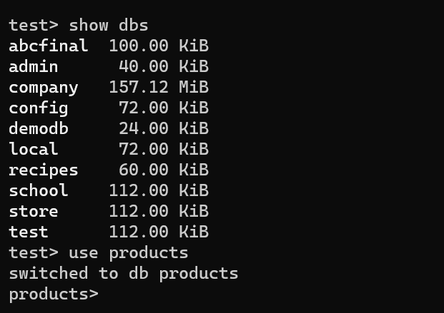

**Import the data from the github link <https://gist.githubusercontent.com/icebeam7/5a3a98e09d45d68f37afb228e790f8ff/raw/d389e0093940a63d6016cd11ed935055c72c4575/products.json> and write The name of the collection as Products_Surname.**

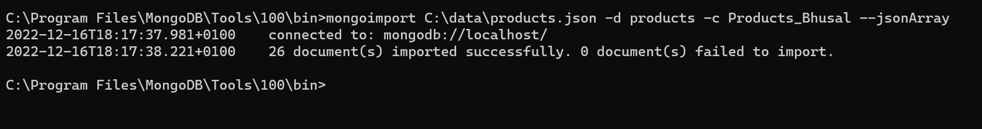

mongoimport C:\data\products.json -d products -c Products_Bhusal --jsonArray

**Add 3 new products at once**

db.Products_Bhusal.insertMany([

{Id: 26, Name: "Dal",ReleaseDate: "2022-07-13",OriginalPrice: 100,Discount: 5,PictureUrl: "https://raw.githubusercontent.com/wedeploy-examples/supermarket-web-example/master/ui/assets/images/26.jpg"},

{Id: 27, Name: "Bhat",ReleaseDate: "2022-07-13",OriginalPrice: 80,Discount: 10,PictureUrl: "https://raw.githubusercontent.com/wedeploy-examples/supermarket-web-example/master/ui/assets/images/27.jpg"},

{Id: 28, Name: "Tarkari",ReleaseDate: "2022-07-13",OriginalPrice: 60,Discount: 2,PictureUrl: "https://raw.githubusercontent.com/wedeploy-examples/supermarket-web-example/master/ui/assets/images/28.jpg"}

])

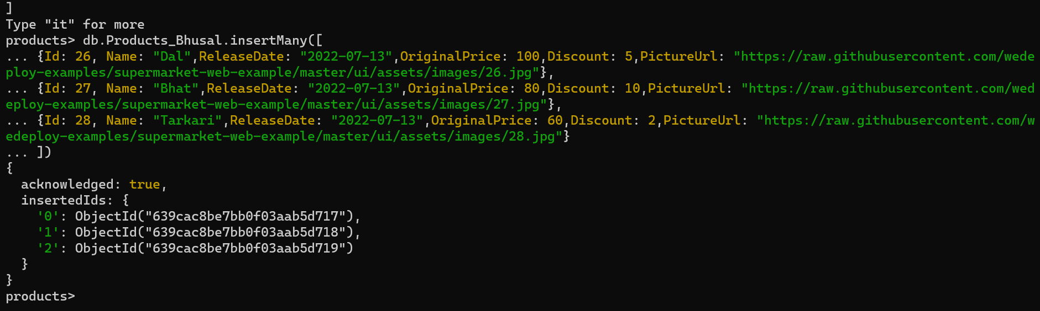

**Delete two items at once**

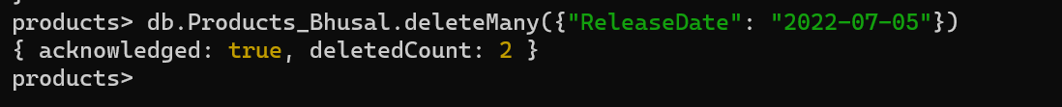

db.Products_Bhusal.deleteMany({"ReleaseDate": "2022-07-05"})

**Define an index over the ReleaseDate field**

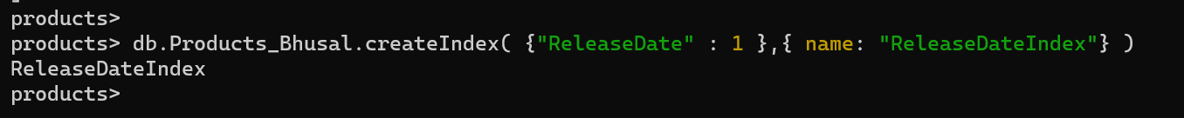

db.Products_Bhusal.createIndex( {"ReleaseDate" : 1 },{ name: "ReleaseDateIndex"} )

**Find:**

1. **All products released between July 1st and 9th, ordered by release date in descending order**

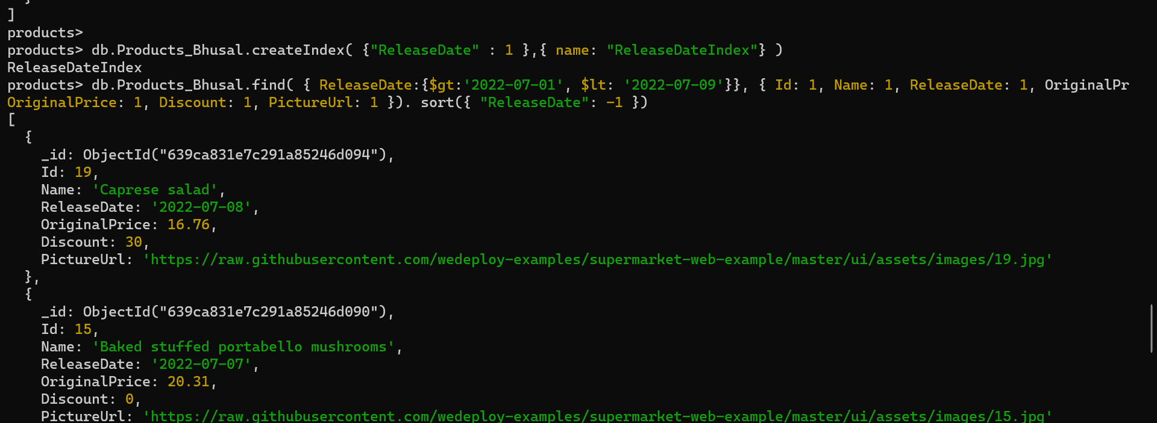

db.Products_Bhusal.find({ReleaseDate:{$gt:'2022-07-01',$lt: '2022-07-09'}},{ Id: 1, Name: 1,ReleaseDate: 1, OriginalPrice:1, Discount:1,PictureUrl:1}).sort({"ReleaseDate":-1})

1. **All products without any discount (that is, discount = 0) order by price**

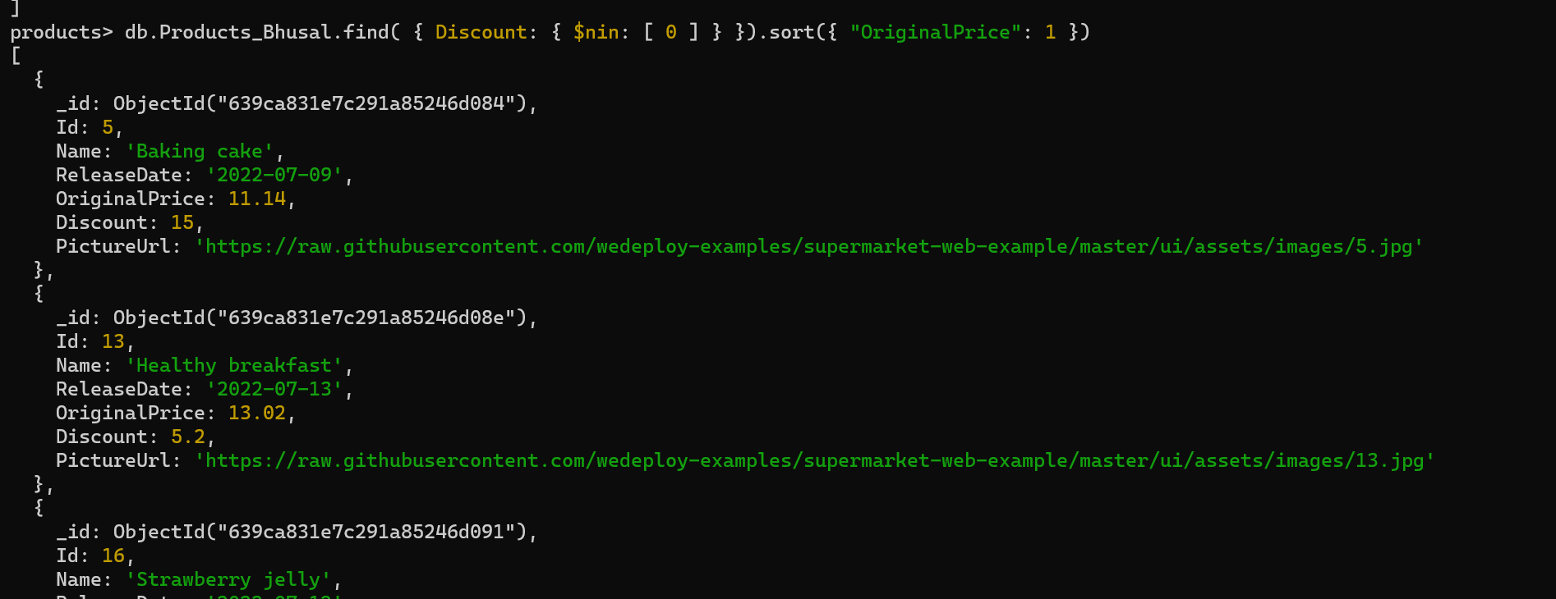

db.Products_Bhusal.find({Discount:{$nin:[0]}}).sort({"OriginalPrice":1})

**Paginate both search results (page size: 5). Return page 2 of results only.**

First search result with product limit to 5 in a page and skip first five products

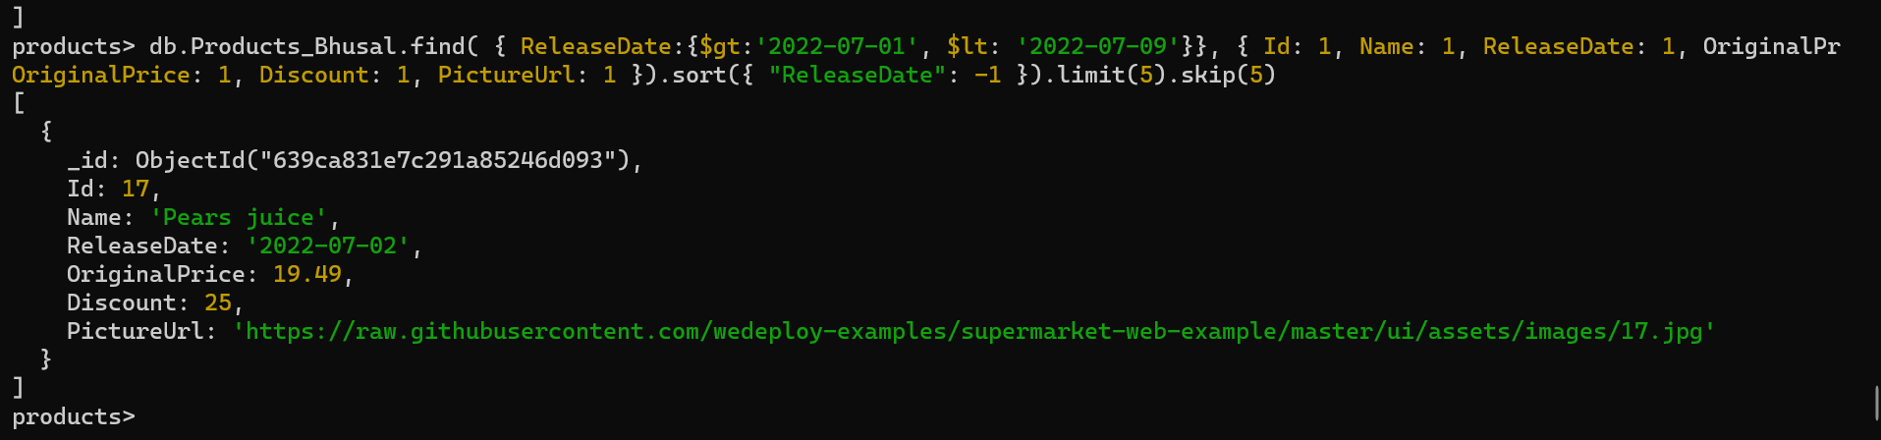

db.Products_Bhusal.find( { ReleaseDate:{$gt:'2022-07-01', $lt: '2022-07-09'}}, { Id: 1, Name: 1, ReleaseDate: 1, OriginalPrice: 1, Discount: 1, PictureUrl: 1 }).sort({ "ReleaseDate": -1 }).limit(5).skip(5)

Second search result with product limit to 5 in a page and skip first five products

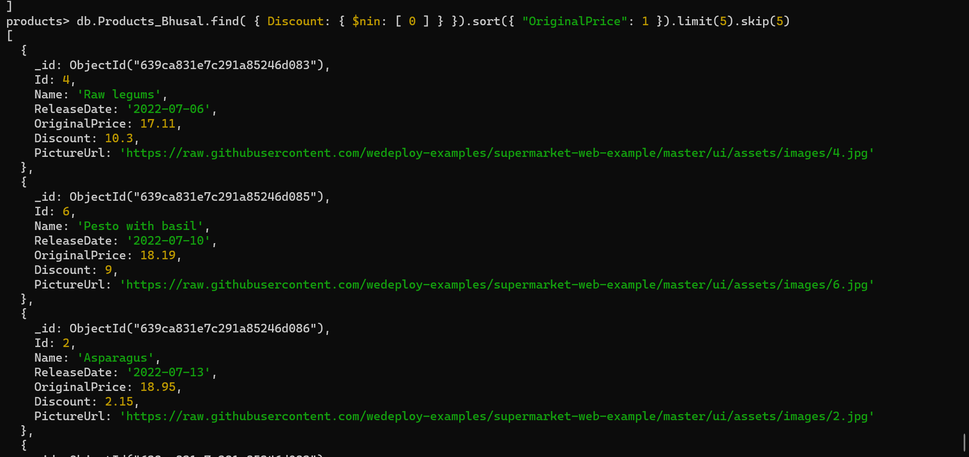

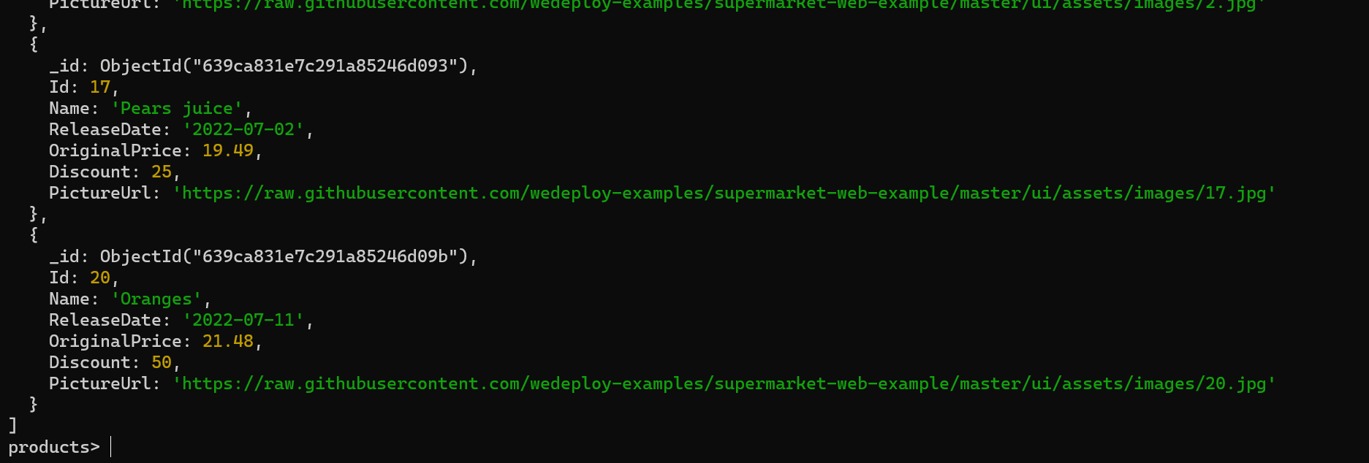

db.Products_Bhusal.find( { Discount: { $nin: [ 0 ] } }).sort({ "OriginalPrice": 1 }).limit(5).skip(5)

**Using an aggregation pipeline, find all products without discount and group them by date; the results must display the group id (date) and a stats field containing the minimum, maximum, and average price of items inside each group.**

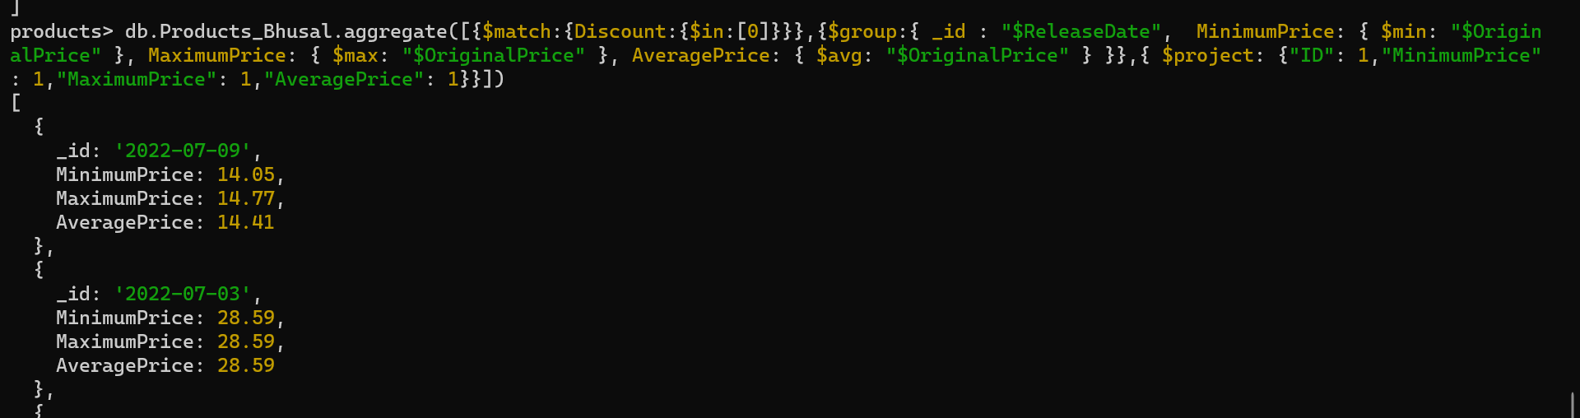

db.Products_Bhusal.aggregate([{$match:{Discount:{$in:[0]}}},{$group:{ _id : "$ReleaseDate",  MinimumPrice: { $min: "$OriginalPrice" }, MaximumPrice: { $max: "$OriginalPrice" }, AveragePrice: { $avg: "$OriginalPrice" } }},{ $project: {"ID": 1,"MinimumPrice": 1,"MaximumPrice": 1,"AveragePrice": 1}}])

Export the final state of the database

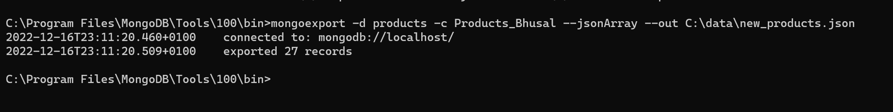

mongoexport -d products -c Products_Bhusal --jsonArray --out C:\data\new_products.json

Create a backup of the Product collection only

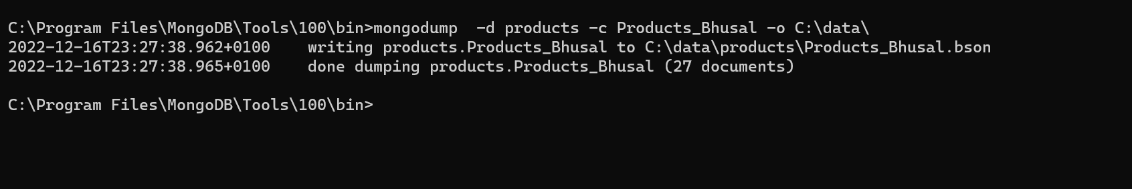

mongodump  -d products -c Products_Bhusal -o C:\data\